Arctic Ocean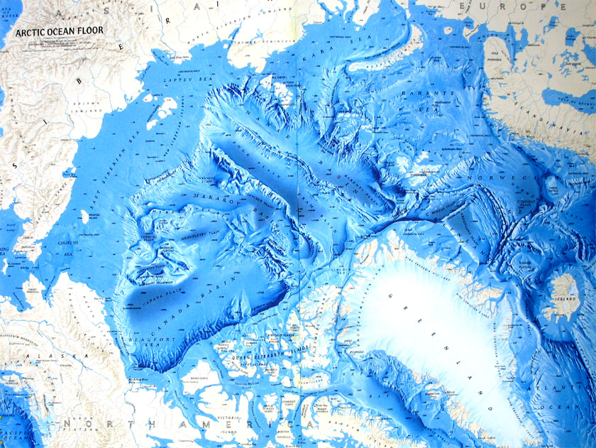

The Arctic Ocean is the smallest ocean. The Arctic Ocean is the only ocean that is completely in the northern hemisphere. The Arctic Ocean has the lowest salt content of all of the other oceans.
Size: The Atlantic Ocean is 5.11 million square miles. It is 12.5 times smaller than the Pacific Ocean.
Average Depth: The average depth of the Atlantic Ocean is 3,953 feet.
Deepest Point: The deepest point in the Arctic Ocean is the Eurasian Basin. It is 3.4 miles deep.
Bordering Countries: The Arctic Ocean is almost completely surrounded by Eurasia and North America. 7 countries total form the borders of the Arctic Ocean.
Average Temperature: The surface temperature of the Arctic Ocean stays around 30 degrees Fahrenheit. Most of the surface is frozen year round.
Fun Fact: The Arctic Ocean is covered with 20 inches of snow 10 months of the year.
The Arctic Ocean gets its name from its geographic location. Some oceanographers refer to the Arctic Ocean as the Arctic Sea because of its size.

